**DAILY ONLINE ACTIVITIES SUMMARY**

|  |  |  |  |  |  |  |  |
| --- | --- | --- | --- | --- | --- | --- | --- |
| **Date:** | | **4/06/2020** | | | | | |
| **Name of the Faculty** | | **Shruthi Shetty J** | | | | | |
| **No. of Students Allotted for monitoring** | | | | | **26** | | |
| **Progress** | | | | | **Good** | | |
| **Whether collected report from all the allotted students** | | | | | **22** | | |
| **Online Test Summary** | | | | | | | |
| **Subject** | **Operation Research test** | | | | | | |
| **Semester** | **6** | | | **Duration** | | **1 HOUR** | |
| **No. of students Taken** | | | **106** | **Passing %** | | **96%** | |
| **Certification Course Summary** | | | | | | | |
| **Course** | | 1. Started with certification course on Network Security on Alison.com. 2. Studying Python Programming language. | | | | | |
| **Certificate Provider** | | **Alison.com, Lecture Notes** | | | **Duration** | | **3+3hours** |
| **Coding Challenges** | | | | | | | |
| **Problem Statement:** Shared set of questions given on Bootcamp. Informed students to solve problem in python programming language. Students can also chose problem statement of their choice. | | | | | | | |
| **Status: 21 completed** | | | | | | | |
| **Uploaded the report in Github** | | | | | **Yes** | | |
| **If yes Repository name** | | | | | <https://github.com/ShruthiShettyJ/daily-report> | | |
| **Uploaded the report in slack** | | | | | **Yes** | | |

Online Test Details: (Attach the snapshot and briefly write the report for the same)

Certification Course Details: (Attach the snapshot and briefly write the report for the same)

Coding Challenges Details: (Attach the snapshot and briefly write the report for the same)

**Certification Course Summary:**

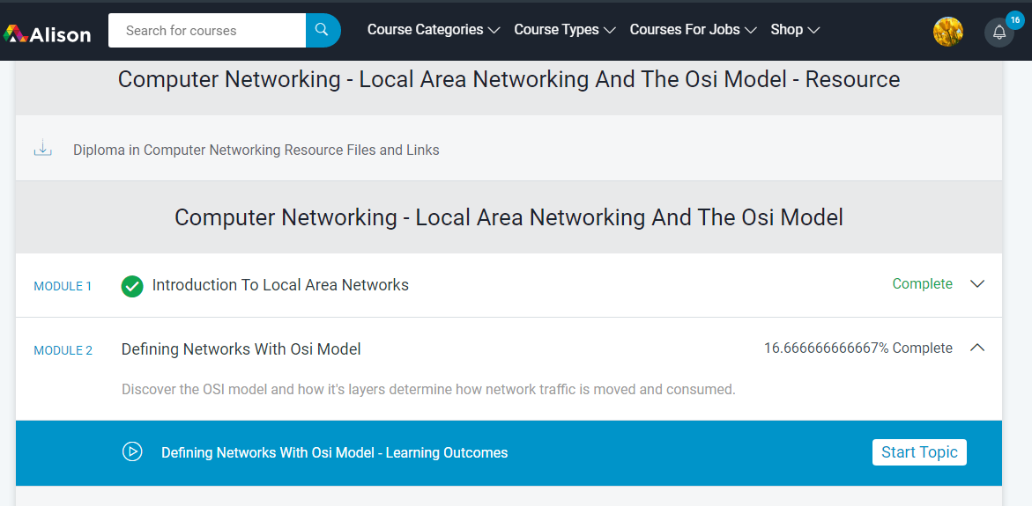

**Sample Students Report:**

